Guillermo Gálvez

CPE301 – SPRING 2018

Design Assignment 4

**DO NOT REMOVE THIS PAGE DURING SUBMISSION:**

The student understands that all required components should be submitted in complete for grading of this assignment.

|  |  |  |  |
| --- | --- | --- | --- |
| **NO** | **SUBMISSION ITEM** | **COMPLETED (Y/N)** | **MARKS**  **(/MAX)** |
| 1 | COMPONENTS LIST |  |  |
| 2. | CODE OF TASK 1 |  |  |
| 3. | CODE OF TASK 2 |  |  |
| 3. | CODE OF TASK 3 |  |  |
| 4. | SCHEMATICS |  |  |
| 5. | SCREENSHOTS OF EACH TASK OUTPUT |  |  |
| 6. | SCREENSHOT OF EACH DEMO |  |  |
| 7. | VIDEO LINKS OF EACH DEMO |  |  |
|  |  |  |  |
|  |  |  |  |
|  |  |  |  |
|  |  |  |  |
|  |  |  |  |

1. **COMPONENTS LIST AND CONNECTION BLOCK DIAGRAM w/ PINS**

ATmega XPlained Mini

Various potentiometers 50Ω – 1MΩ

Generic DC motor

PX243 Stepper Motor

HD 3001HB Servo Motor

ULN 2003 Driver IC

L293DNE Driver IC

1. **CODE OF TASK 1**
2. */\**
3. *\* da4T1.c*
4. *\**
5. *\* Created: 4/13/2018 08:35:25 PM*
6. *\* Author : Guillermo Galvez*
7. *\*/*
8. #define F_CPU 1000000UL
9. #include <avr/io.h>
10. #include <util/delay.h>
11. #include <stdlib.h>
12. #include <avr/interrupt.h>
13. *//Global variables*
14. **volatile** uint8_t speed;
15. int toggle = 0;
16. *//Functions Declarations*
17. void ADC_Init();
18. void timeKepper();
19. void interrupts();
20. void on_off();
21. ISR(ADC_vect)
22. {
23. ADCSRA |= (1 << ADIF); *//set ADIF 1*
24. }*//end ADC_vect*
25. ISR(TIMER0_OVF_vect)
26. {
27. *//PORTB = 0x01; //Toggle on Start of new period*
29. ADCSRA |= (1 << ADSC); *//Start Conversion*
30. **while**((ADCSRA & (1 << ADIF)) == 0);
32. speed = ADCH;
34. *//Control DC from 0 to 95 of total TIMER1 Ticks at 1024 Pre-Scale*
35. *//OC1A Drives motor and Toggles on compare of of OCR1A*
36. *//Creating a PWM wave*
37. **if**(speed >= 242) *//242 95% of ADCH*
38. {
39. OCR1A = 7422; *//95% of 7813 total timer ticks for 1024 Pre-Scale Max*
40. }
41. **else**
42. {
43. OCR1A = speed * 32.3; *//Conversion of 8-bit ADCH to Timer1 counter range*
44. }
45. }*//end TIMER0_OVF_vect*
46. *//This was a failure unable to keep*
47. *//Motor only stays off while pressed*
48. ISR(INT0_vect)
49. {
50. EIFR |= (1 << INTF0);
51. _delay_ms(1000); *//Debouncing*
52. **while**(!(PIND & (1 << PIND2)) == 0); *//Pull-up resistor switch to ground*
53. }*//end ISR(INT0_vect)*
54. int main(void)
55. {
56. DDRB = 0x02; *//Set PINB1 as output*
57. DDRD |= (1 << DDD6); *//Set to output for OCA0*
58. ;
59. OCR1A = 25000; *//Arbritary initial value for OCR1A*
61. *//Functions to initialize*
62. *//ADC, TIMER1 and Interrupts*
63. ADC_Init();
64. timeKepper();
65. interrupts();
67. **while** (1)
68. {
69. }*//end while(1)*
71. }*//end MAIN*
72. void ADC_Init()
73. {
74. DDRC = 0; *//Set PORTC as input for adc*
75. DIDR0 = 0x01; *//Disable Digi input on ADC0*
77. ADMUX = 0; *//Sets Mux selection bits to 0 ADC0 used*
78. ADMUX |= (1 << REFS0); *//Use Vcc Ref voltage selectin 01*
79. ADMUX |= (1 << ADLAR); *//Left adjust ADC Reg, ADCH 8-bit Resolution*
81. *//Enable ADC, Start Conv, Set Auto Trig Enable*
82. ADCSRA |= (1 << ADEN); *//Enable ADC*
83. ADCSRA |= (1 << ADATE); *//Set ADC Auto Trig*
84. ADCSRA |= (1 << ADIE); *//Enable Interrupts*
85. ADCSRA |= (1 << ADPS2) | (1 << ADPS1) | (0 << ADPS0); *//8MHz, Pre-Scale 64 = 125KHz*
86. ADCSRA |= (1 << ADSC); *//Start Conversion*
88. ADCSRB = 0; *//Free running mode*
89. sei(); *//Enable interrupts*
91. }*//end ADC_Init*
92. void timeKepper()
93. {
94. TCCR1A |= (1 << COM1A1) | (1 << WGM11) | (1 << WGM10); *//Clear OC1A on Compare Match, set OC1A at BOTTOM (non-inverting mode)*
95. TCCR1B |= (1 << WGM13) | (1 << WGM12) | (1 << CS12) | (1 << CS10); *//PWM Fast mode 1024 Pre-Scale*
96. TIMSK1 |= (1 << TOIE1);
97. }*//end timekeeper*
98. void interrupts()
99. {
100. DDRD |= (1 << PD2); *//Set to input for switch*
101. PORTD |= (1 << PD2); *//Set Pull-up*
102. EIMSK |= (1 << INT0); *//Enable extern INT0*
103. EICRA |= (1 << ISC01); *//Enanble external INT0 on rise*
104. }*//enterrupt*
105. **CODE OF TASK 2**

*/\**

*\* da4_galveg1.c*

*\**

*\* Created: 4/11/2018 05:01:07 PM*

*\* Author : Guillermo Gálvez*

*\*/*

#define F_CPU 8000000UL

#include <avr/io.h>

#include <util/delay.h>

#include <stdio.h>

#include <avr/interrupt.h>

**volatile** uint8_t speed; *//variable to hold ADC value*

*//uint8_t speed_Low = 0;*

*//uint16_t ten_bit = 0;*

ISR(ADC_vect)

{

ADCSRA |= (1 << ADIF); *//set ADIF 1*

speed = ADCH;

*//OCR1AL = ADCL;*

*//OCR1AH = ADCH;*

}*//end ADC_vect*

ISR(TIMER1_OVF_vect)

{

}*//end OVF_vect*

ISR(TIMER1_COMPA_vect)

{

_delay_ms(2);

}*//end COMP1_vect*

void my_delay();

int main(void)

{

DDRD = 0b00001111; *//set PIND0-PIND3 to output*

TIFR1 |= (1 << OCF1A); *//Enable Out Comp A match INT*

TIMSK1 |= (1 << OCIE1A); *//enable CompA INT*

TCCR1A = 0;

TCCR1B = 0;

*//set to CTC mode*

TCCR1A = 0; *//set WGM11 = 0, WGM10 = 0*

TCCR1B |= (1 << WGM12) | (1 << CS12); *//set WGM13 = 0, WGM12 = 1 CTC, Pre-scale = 256*

*//set Output Compare Register to calculated count(compared*

OCR1A = 156;

DDRD = 0xFF; *//set D port to output*

ADC_Init(); *//initialize ADC*

sei(); *//Enable Interrupts*

**while** (1)

{

ADCSRA |= (1 << ADSC); *//Start Conversion*

**while**((ADCSRA & (1 << ADIF)) == 0);

OCR1A = speed * .75;

PORTD = 1; *//black*

my_delay();

PORTD = 2; *//green*

my_delay();

PORTD = 4; *//red*

my_delay();

PORTD = 8; *//blue*

my_delay();

*/\**

*PORTD = 1; //black*

*while((TIFR1 & (1 << OCF1A)) == 0);*

*PORTD = 4; //green*

*while((TIFR1 & (1 << OCF1A)) == 0);*

*PORTD = 2; //red*

*while((TIFR1 & (1 << OCF1A)) == 0);*

*PORTD = 8; //blue*

*while((TIFR1 & (1 << OCF1A)) == 0);*

*\*/*

*/\**

*PORTD = 1; //black*

*_delay_ms(2);*

*PORTD = 2; //red*

*_delay_ms(2);*

*PORTD = 4; //red*

*_delay_ms(2);*

*PORTD = 8; //blue*

*_delay_ms(2);*

*\*/*

}*//end while*

}*//end main*

void ADC_Init()

{

DDRC = 0; *//Set PORTC as input for adc*

DIDR0 = 0x01; *//Disable Digi input on ADC0*

ADMUX = 0; *//*

ADMUX |= (1 << REFS0); *//Use Vcc Ref voltage*

ADMUX |= (1 << ADLAR); *//Left adjust ADC Reg, 8-bit Resolution*

*//Enable ADC, Start Conv, Set Auto Trig Enable*

ADCSRA |= (1 << ADEN); *//Enable ADC*

ADCSRA |= (1 << ADATE); *//Set ADC Auto Trig*

ADCSRA |= (1 << ADIE); *//Enable Interrupts*

ADCSRA |= (1 << ADPS2) | (1 << ADPS1) | (0 << ADPS0); *//8MHz, Pre-Scale 64 = 125KHz*

ADCSRA |= (1 << ADSC); *//Start Conversion*

ADCSRB = 0; *//Free running mode*

sei(); *//Enable interrupts*

}*//end ADC_Init*

void my_delay()

{

**while**(TCNT1 != OCR1A);

TCNT1 = 0;

*//while((TIFR1 & (1 << OCF1A)) == 0);*

}

1. **CODE OF TASK 3**

*/\**

*\* da4T3galveg1.c*

*\**

*\* Created: 4/14/2018 03:23:32 PM*

*\* Author : Guillermo Galvez*

*\*/*

#define F_CPU 8000000UL

#include <avr/io.h>

#include <util/delay.h>

#include <avr/interrupt.h>

*//Variable Declarations*

**volatile** unsigned int PWMOUT; *// output for PWM duty cycle*

void timekeeper();

void adc_init();

int main(void)

{

*//Port initialization*

DDRB = 0x02; *//Set PB1 OC1A as output to generate PWM*

timekeeper();

adc_init();

**while** (1)

{

ADCSRA |= (1 << ADSC); *//Start conversion*

**while**((ADCSRA & (1 << ADIF)) == 0); *//Wait for conversion to finish*

PWMOUT = (ADC & 0x03FF) * 24 / 10+800; *//OCR1A value for duty cycle*

OCR1A = PWMOUT;

}*//end while(1)*

}*//end MAIN*

void timekeeper()

{

*//TIMER1 initialization - generate 50Hz PWM*

TCCR1A |= (1 << COM1A1) | (1 << WGM11); *// Fast PWM, Non-inverted mode*

TCCR1B |= (1 << WGM13) | (1<< WGM12) | (1 << CS11); *// 8 prescaling*

*//TIMSK1 |= (1 << TOIE1);*

ICR1 = 9999; *// top value for timer1*

}

void adc_init()

{

DDRC = 0; *//Set PORTC as input for adc*

DIDR0 = 0x01; *//Disable Digi input on ADC0*

ADMUX = 0; *//*

ADMUX |= (1 << REFS0); *//Use Vcc Ref voltage*

*//ADMUX |= (1 << ADLAR); //Left adjust ADC Reg, 8-bit Resolution*

*//Enable ADC, Start Conv, Set Auto Trig Enable*

ADCSRA |= (1 << ADEN); *//Enable ADC*

*//ADCSRA |= (1 << ADATE); //Set ADC Auto Trig*

*//ADCSRA |= (1 << ADIE); //Enable Interrupts*

ADCSRA |= (1 << ADPS2) | (1 << ADPS1) | (1 << ADPS0); *//8MHz, Pre-Scale 128 = 62500KHz*

ADCSRA |= (1 << ADSC); *//Start Conversion*

ADCSRB = 0; *//Free running mode*

sei(); *//Enable interrupts*

}

1. **SCHEMATICS**

Use fritzing.org 🡨 Attempted again but still freezes

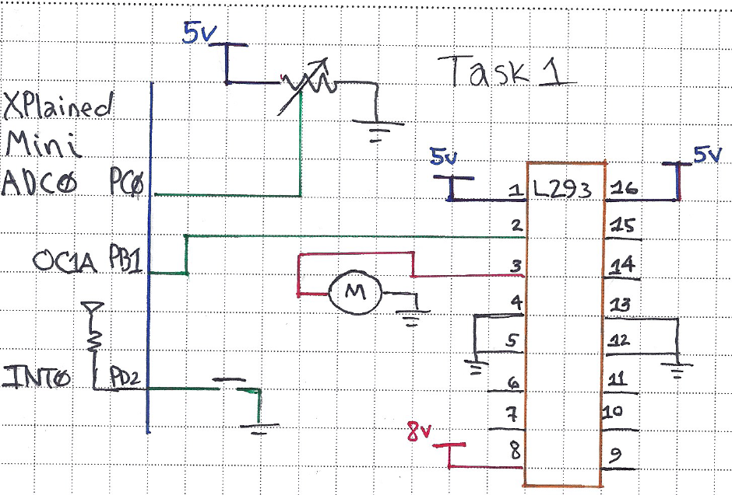

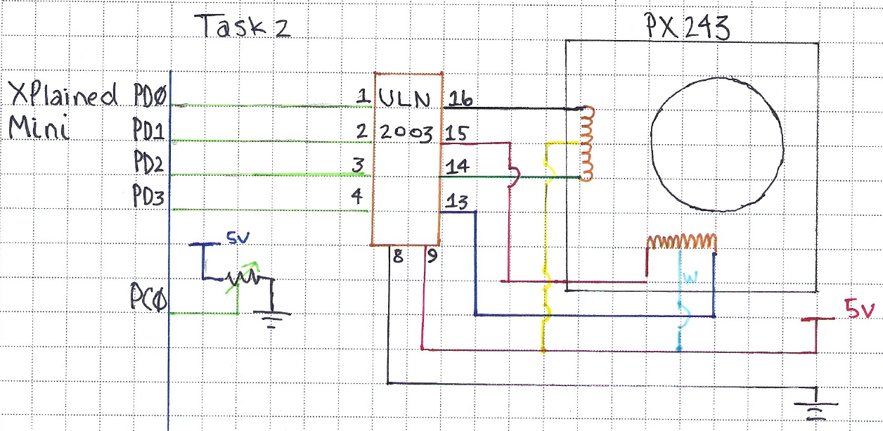

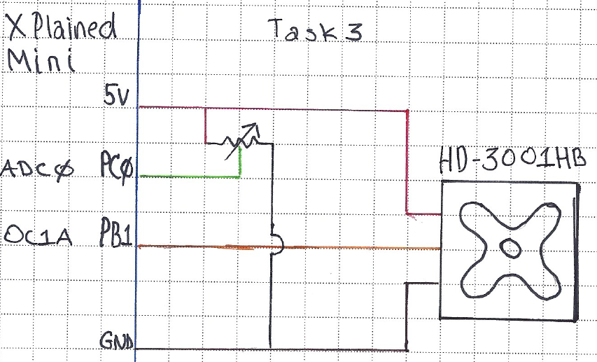

1. **SCREENSHOTS OF EACH TASK OUTPUT (ATMEL STUDIO OUTPUT)**

**N/A**

1. **SCREENSHOT OF EACH DEMO (BOARD SETUP)**

**Task 1**

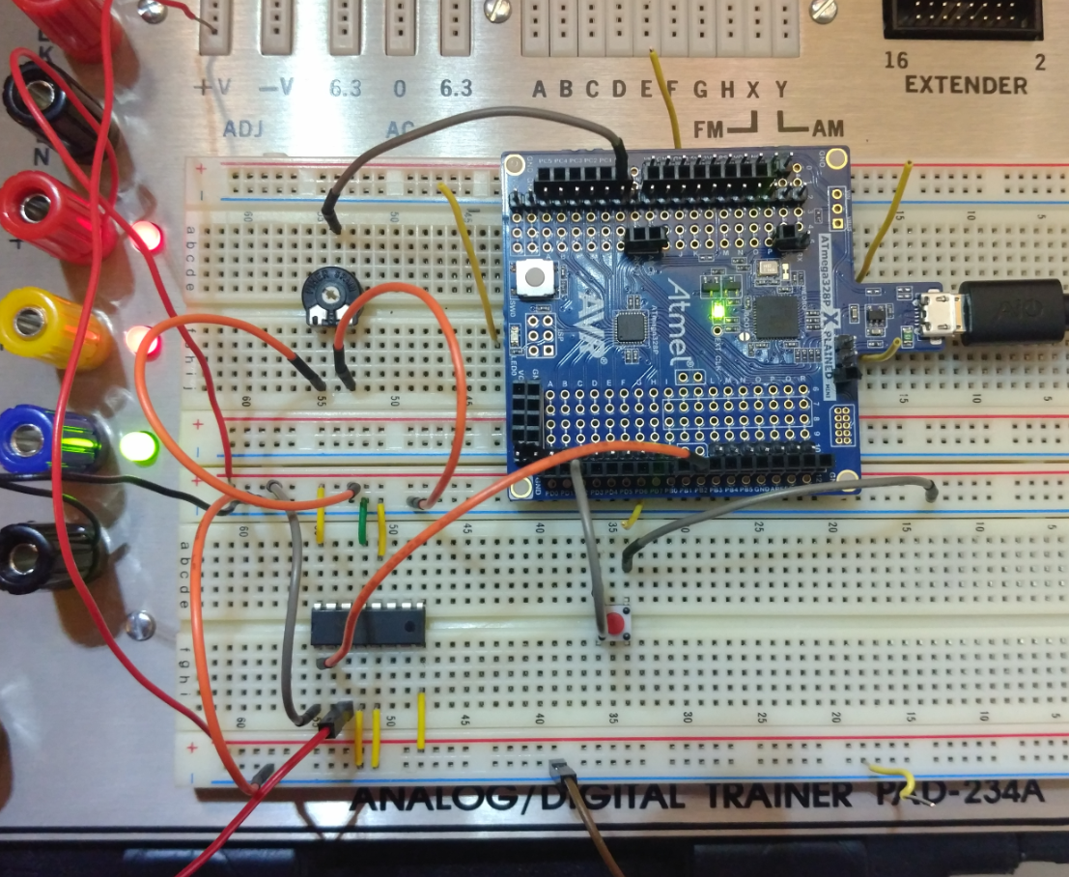

**Task 2**

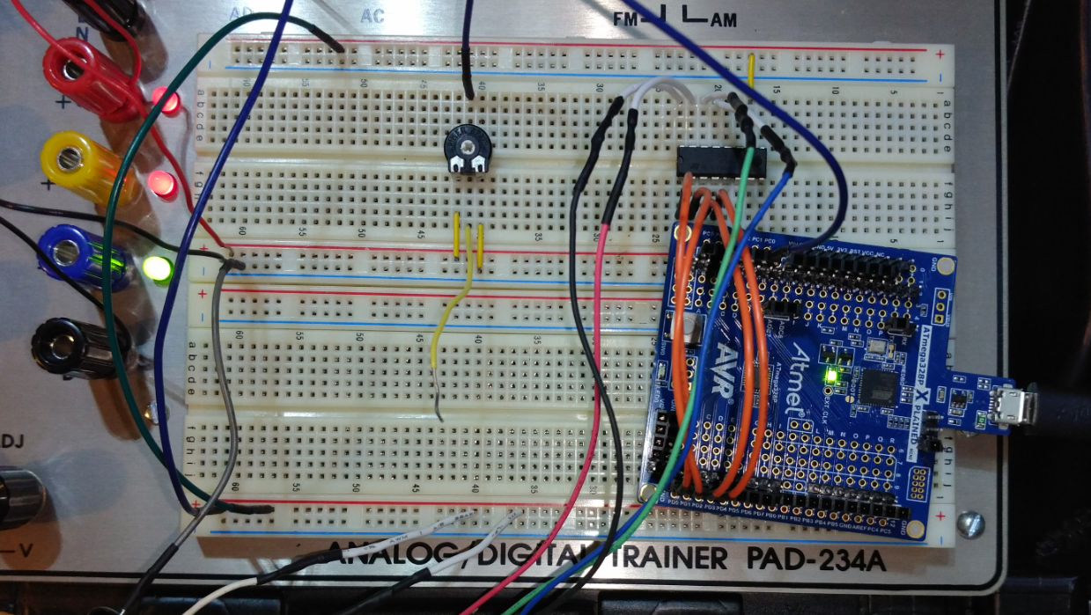

**Task 3**

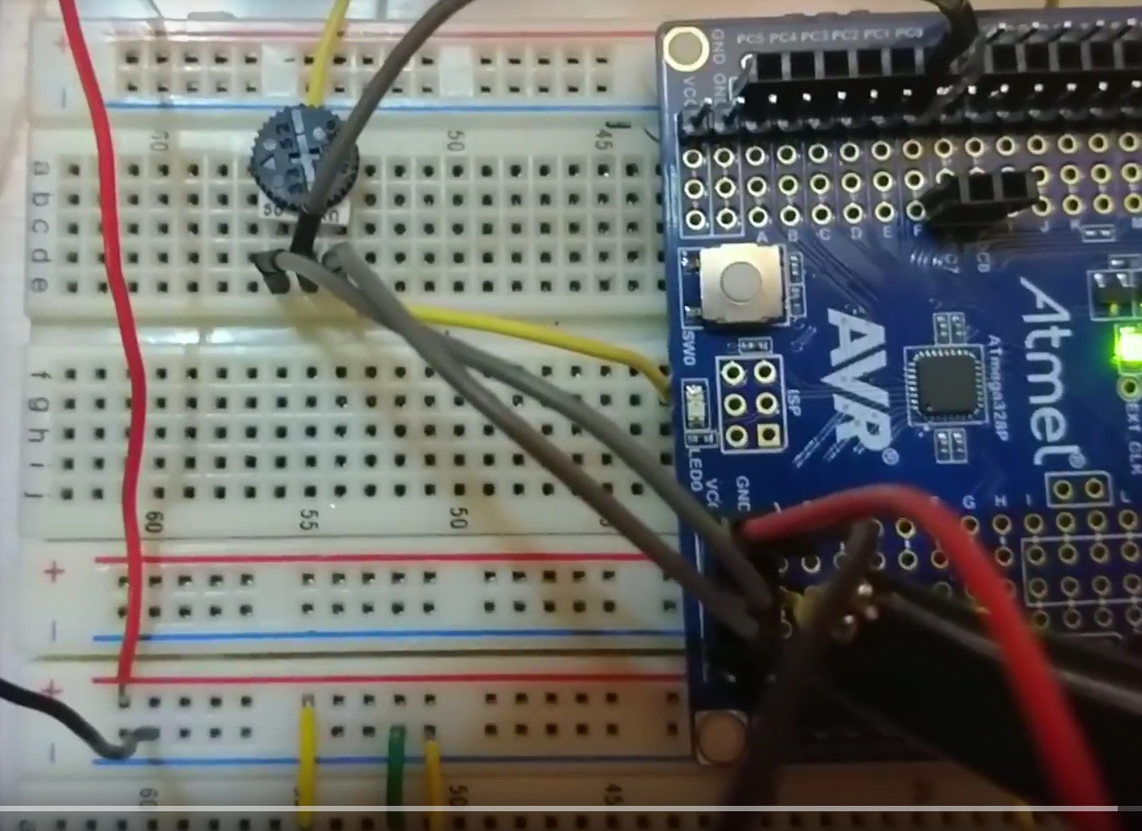

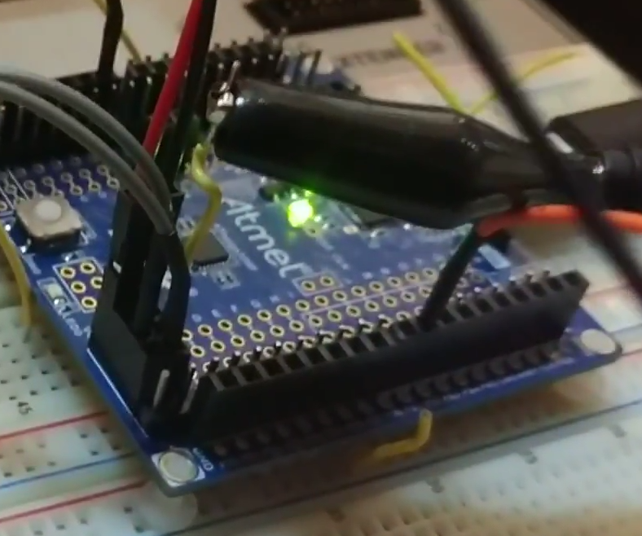

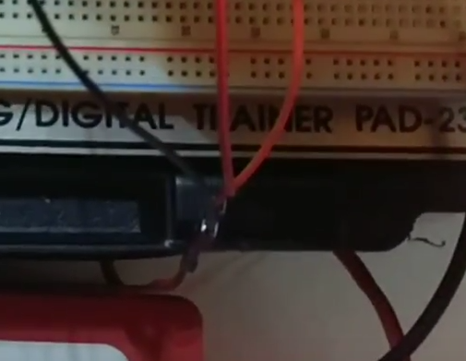

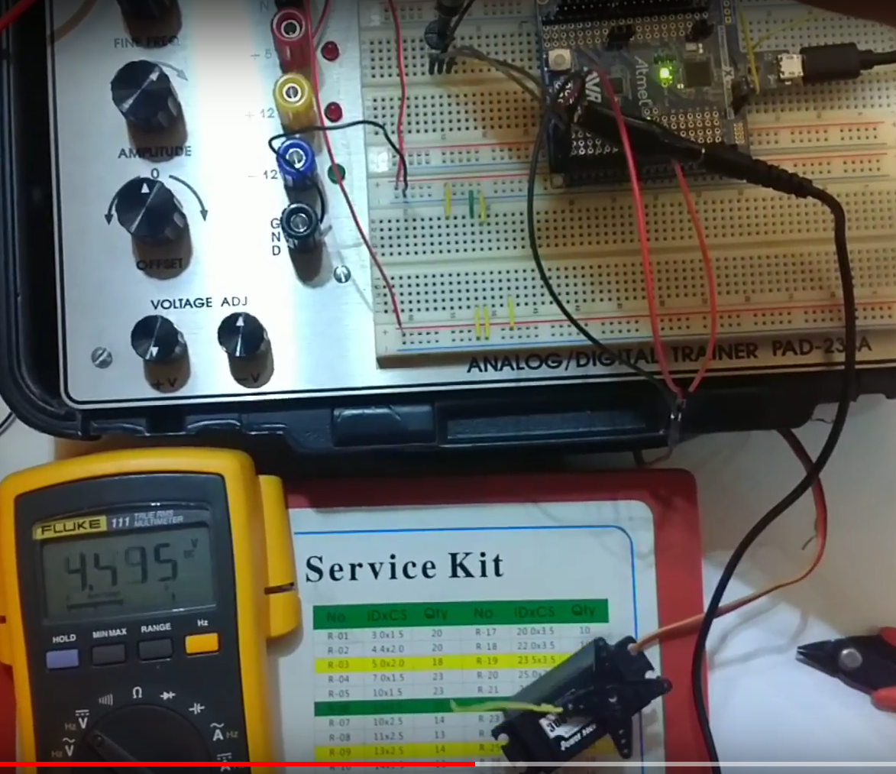

1. **VIDEO LINKS OF EACH DEMO**

**T1** <https://youtu.be/ez7QHmx578g>

**T2** <https://youtu.be/H0f1BSl8-OU>

**T3** <https://youtu.be/ty1ZOf6aa7o>

1. **GITHUB LINK OF THIS DA**

<https://github.com/galveg1/Design-Assignments/tree/master/DA4>

**Student Academic Misconduct Policy**

<http://studentconduct.unlv.edu/misconduct/policy.html>

“This assignment submission is my own, original work”.

Guillermo Gálvez